NAME : Khush Pithva (24BCE174)
SUBJECT : DIGITAL ELECTRONICS (2CS507CC23)
PRACTICAL NO.: 6
AIM: Demonstrate the working of basic logic gates and verify it with Verilog HDL.

AND GATE
CODE:
module and_gate(
input A, input B, output Y
);
assign Y = A & B;
endmodule module and_gate_tb;
reg tb_A; reg tb_B; wire tb_Y; and_gate dut(
.A(tb_A),
.B(tb_B),
.Y(tb_Y)
);
initial begin tb_A = 1'b0; tb_B = 1'b0; #10; // A=0, B=0, wait 10 time units tb_A = 1'b0; tb_B = 1'b1; #10; // A=0, B=1, wait 10 time units tb_A = 1'b1; tb_B = 1'b0; #10; // A=1, B=0, wait 10 time units tb_A = 1'b1; tb_B = 1'b1; #10; // A=1, B=1, wait 10 time units
$finish ;
end initial begin
$monitor("Time=%0t: A=%b, B=%b, Y=%b", $time, tb_A, tb_B, tb_Y);
end
endmodule OUTPUT:
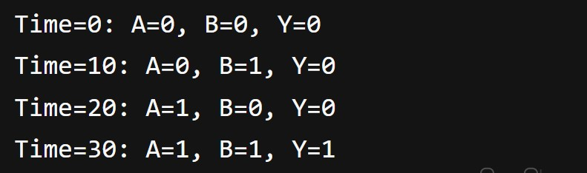

OR GATE

CODE:
module or_gate(
input A, input B, output Y
);
assign Y = A || B;
endmodule module or_gate_tb;
reg tb_A; reg tb_B; wire tb_Y; or_gate dut( .A(tb_A),
.B(tb_B),
.Y(tb_Y)
);
initial begin tb_A = 1'b0; tb_B = 1'b0; #10; // A=0, B=0, wait 10 time units tb_A = 1'b0; tb_B = 1'b1; #10; // A=0, B=1, wait 10 time units tb_A = 1'b1; tb_B = 1'b0; #10; // A=1, B=0, wait 10 time units tb_A = 1'b1; tb_B = 1'b1; #10; // A=1, B=1, wait 10 time units
$finish ; end initial begin
$monitor("Time=%0t: A=%b, B=%b, Y=%b", $time, tb_A, tb_B, tb_Y);
end
endmodule OUTPUT:
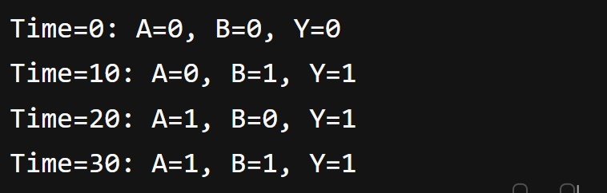

NAND GATE

CODE:
module nand_gate(
input A, input B, output Y
);
assign Y = ~(A & B);
endmodule module nand_gate_tb;
reg tb_A; reg tb_B; wire tb_Y; nand_gate dut(
.A(tb_A),
.B(tb_B),
.Y(tb_Y)
);
initial begin tb_A = 1'b0; tb_B = 1'b0; #10; // A=0, B=0, wait 10 time units tb_A = 1'b0; tb_B = 1'b1; #10; // A=0, B=1, wait 10 time units tb_A = 1'b1; tb_B = 1'b0; #10; // A=1, B=0, wait 10 time units tb_A = 1'b1; tb_B = 1'b1; #10; // A=1, B=1, wait 10 time units
$finish ; end initial begin $monitor("Time=%0t: A=%b, B=%b, Y=%b", $time, tb_A, tb_B, tb_Y);
end
endmodule OUTPUT:
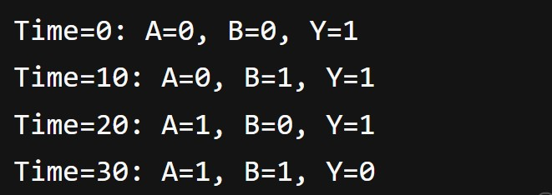

NOR GATE

CODE:
module nand_gate(
input A, input B, output Y
);
assign Y = ~(A & B);
endmodule module nand_gate_tb;
reg tb_A; reg tb_B; wire tb_Y; nand_gate dut(
.A(tb_A),
.B(tb_B),
.Y(tb_Y)
);
initial begin tb_A = 1'b0; tb_B = 1'b0; #10; // A=0, B=0, wait 10 time units tb_A = 1'b0; tb_B = 1'b1; #10; // A=0, B=1, wait 10 time units tb_A = 1'b1; tb_B = 1'b0; #10; // A=1, B=0, wait 10 time units tb_A = 1'b1; tb_B = 1'b1; #10; // A=1, B=1, wait 10 time units
$finish ; end initial begin
$monitor("Time=%0t: A=%b, B=%b, Y=%b", $time, tb_A, tb_B, tb_Y);
end
endmodule OUTPUT:
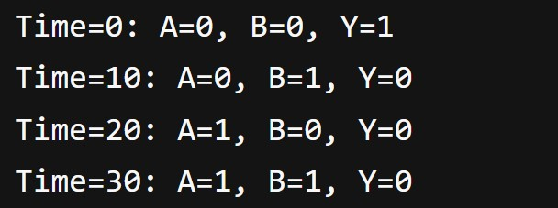

X-OR GATE

CODE:
module nand_gate(
input A, input B, output Y); assign Y = ~(A & B); endmodule module nand_gate_tb;
reg tb_A; reg tb_B; wire tb_Y; nand_gate dut(
.A(tb_A),
.B(tb_B),
.Y(tb_Y)
);
initial begin tb_A = 1'b0; tb_B = 1'b0; #10; // A=0, B=0, wait 10 time units tb_A = 1'b0; tb_B = 1'b1; #10; // A=0, B=1, wait 10 time units tb_A = 1'b1; tb_B = 1'b0; #10; // A=1, B=0, wait 10 time units tb_A = 1'b1; tb_B = 1'b1; #10; // A=1, B=1, wait 10 time units
$finish ; end initial begin
$monitor("Time=%0t: A=%b, B=%b, Y=%b", $time, tb_A, tb_B, tb_Y);
end
endmodule OUTPUT:
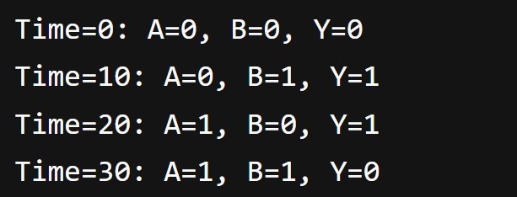
X-NOR GATE

CODE:
module nand_gate(
input A, input B, output Y
);
assign Y = ~(A & B);
endmodule module nand_gate_tb;
reg tb_A; reg tb_B; wire tb_Y; nand_gate dut(
.A(tb_A),
.B(tb_B),
.Y(tb_Y)
);
initial begin tb_A = 1'b0; tb_B = 1'b0; #10; // A=0, B=0, wait 10 time units tb_A = 1'b0; tb_B = 1'b1; #10; // A=0, B=1, wait 10 time units tb_A = 1'b1; tb_B = 1'b0; #10; // A=1, B=0, wait 10 time units tb_A = 1'b1; tb_B = 1'b1; #10; // A=1, B=1, wait 10 time units
$finish ; end initial begin $monitor("Time=%0t: A=%b, B=%b, Y=%b", $time, tb_A, tb_B, tb_Y);
end
endmodule OUTPUT:
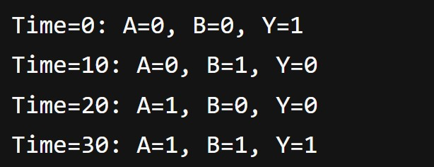

NOT GATE
CODE:
module not_gate(
input A, output Y
);
assign Y = ~(A);
endmodule module not_gate_tb;
reg tb_A; wire tb_Y; not_gate dut(
.A(tb_A),
.Y(tb_Y)
);
initial begin tb_A = 1'b0; #10; // A=0,wait 10 time units tb_A = 1'b1; #10; // A=1,wait 10 time units
$finish ; end initial begin
$monitor("Time=%0t: A=%b, Y=%b", $time, tb_A, tb_Y);
end
endmodule OUTPUT :
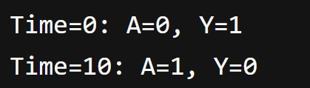

NAME : KHUSH PITHVA (24BCE174)
SUBJECT : DIGITAL ELECTRONICS (2CS507CC23)
PRACTICAL NO.: 6
AIM: Design and Implementation of Half and Full Adder and Subtractor circuits.

HALF ADDER
CODE:
module half_adder(
input A, input B, output Y, output carry
);
assign Y = A ^ B; assign carry = A & B; endmodule module half_adder_tb; reg tb_A; reg tb_B; wire tb_Y; wire tb_carry; half_adder dut(
.A(tb_A),
.B(tb_B),
.Y(tb_Y),
.carry(tb_carry)
); initial begin tb_A = 1'b0; tb_B = 1'b0; #10; tb_A = 1'b0; tb_B = 1'b1; #10; tb_A = 1'b1; tb_B = 1'b0; #10; tb_A = 1'b1; tb_B = 1'b1; #10;
$finish ; end
initial
begin
$monitor("Time=%0t: A=%b, B=%b, Y=%b, carry=%b", $time, tb_A, tb_B, tb_Y, tb_carry); end endmodule
OUTPUT :
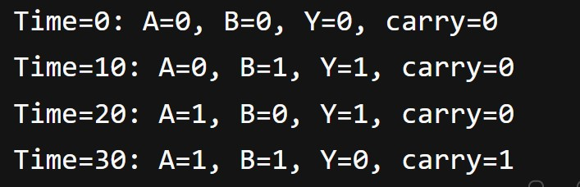

FULL ADDER

CODE:
module full_adder( input A, input B, input C, output Y,
output carry
);

assign Y = A ^ B ^ C; assign carry = (A & B) || (A ^ B) & C;

endmodule

module full_adder_tb; reg tb_A; reg tb_B; reg tb_C; wire tb_Y;
wire tb_carry;

full_adder dut(
.A(tb_A),
.B(tb_B),
.C(tb_C),
.Y(tb_Y),
.carry(tb_carry)
);

initial begin tb_A = 1'b0; tb_B = 1'b0; tb_C = 1'b0; #10; tb_A = 1'b0; tb_B = 1'b0; tb_C = 1'b1; #10; tb_A = 1'b0; tb_B = 1'b1; tb_C = 1'b0; #10; tb_A = 1'b0; tb_B = 1'b1; tb_C = 1'b1; #10; tb_A = 1'b1; tb_B = 1'b0; tb_C = 1'b0; #10; tb_A = 1'b1; tb_B = 1'b0; tb_C = 1'b1; #10; tb_A = 1'b1; tb_B = 1'b1; tb_C = 1'b0; #10;
tb_A = 1'b1; tb_B = 1'b1; tb_C = 1'b1; #10;

$finish ; end
initial begin
$monitor("Time=%0t: A=%b, B=%b, C=%b, Y=%b, carry=%b", $time, tb_A, tb_B, tb_C, tb_Y, tb_carry); end endmodule

OUTPUT :

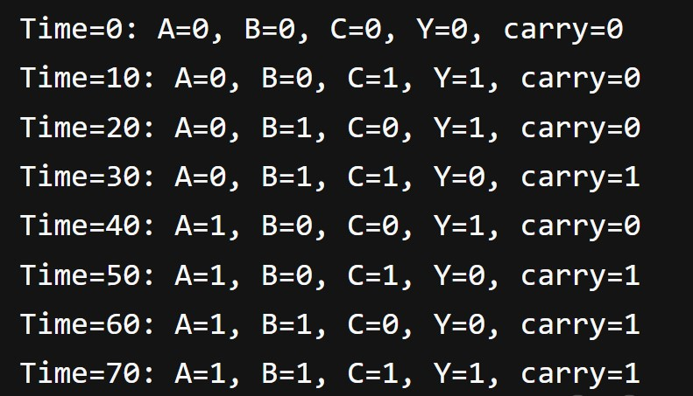

HALF ADDER
CODE :
module half_sub(
input A, input B, output Y, output borrow
);
assign Y = A ^ B; assign borrow = ~A & B; endmodule module half_sub_tb; reg tb_A; reg tb_B; wire tb_Y; wire tb_borrow; half_sub dut( .A(tb_A),
.B(tb_B),
.Y(tb_Y),
.borrow(tb_borrow)
);
initial begin tb_A = 1'b0; tb_B = 1'b0; #10; tb_A = 1'b0; tb_B = 1'b1; #10; tb_A = 1'b1; tb_B = 1'b0; #10; tb_A = 1'b1; tb_B = 1'b1; #10;
$finish ;
end
initial
begin
$monitor("Time=%0t: A=%b, B=%b, Y=%b, borrow=%b", $time, tb_A, tb_B, tb_Y, tb_borrow);
End
endmodule
OUTPUT :
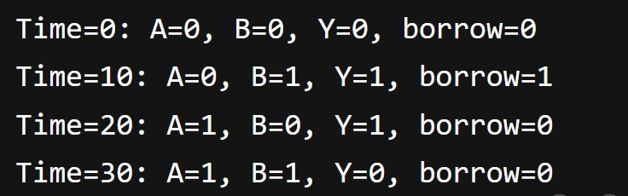

FULL SUBSTRACTOR

CODE :
module full_sub(
input A, input B, input C, output Y, output borrow
);
assign Y = A ^ B ^ C; assign borrow = (~A & B) || (~A ^ B) & C; endmodule module full_sub_tb; reg tb_A; reg tb_B; reg tb_C; wire tb_Y; wire tb_borrow; full_sub dut( .A(tb_A),
.B(tb_B),
.C(tb_C),
.Y(tb_Y),
.borrow(tb_borrow)
); initial begin tb_A = 1'b0; tb_B = 1'b0; tb_C = 1'b0; #10; tb_A = 1'b0; tb_B = 1'b0; tb_C = 1'b1; #10; tb_A = 1'b0; tb_B = 1'b1; tb_C = 1'b0; #10; tb_A = 1'b0; tb_B = 1'b1; tb_C = 1'b1; #10; tb_A = 1'b1; tb_B = 1'b0; tb_C = 1'b0; #10; tb_A = 1'b1; tb_B = 1'b0; tb_C = 1'b1; #10; tb_A = 1'b1; tb_B = 1'b1; tb_C = 1'b0; #10; tb_A = 1'b1; tb_B = 1'b1; tb_C = 1'b1; #10;
$finish ; end
initial
begin
$monitor("Time=%0t: A=%b, B=%b, C=%b, Y=%b, borrow=%b", $time, tb_A, tb_B, tb_C, tb_Y, tb_borrow); end endmodule
OUTPUT :
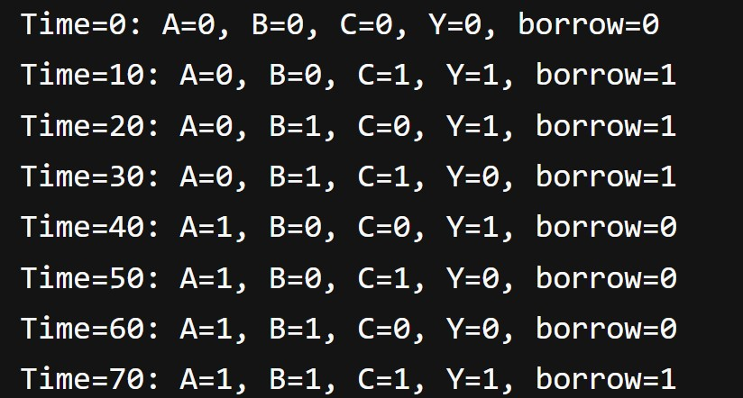

NAME : KHUSH PITHVA (24BCE174)
SUBJECT : DIGITAL ELECTRONICS (2CS507CC23)
PRACTICAL NO.: 6
AIM: Design and Implementation of a combination circuit that converts the given BCD number into an equivalent 2421 number.

CODE:
module BCD(
input A, input B, input C, input D, output W, output X, output Y, output Z
);

assign W = (B & D) || (B & C) || A; assign X = (B & ~D) || (B & C) || A; assign Y = (~B & C) || (B & ~C & D) || A ; assign Z = D ;

endmodule

module BCD_tb; reg tb_A; reg tb_B; reg tb_C;
reg tb_D; wire tb_W; wire tb_X; wire tb_Y; wire tb_Z;

BCD dut(
.A(tb_A),
.B(tb_B),
.C(tb_C),
.D(tb_D),
.W(tb_W),
.X(tb_X),
.Y(tb_Y),
.Z(tb_Z)
);

initial begin tb_A = 1'b0; tb_B = 1'b0; tb_C = 1'b0; tb_D = 1'b0; #10; tb_A = 1'b0; tb_B = 1'b0; tb_C = 1'b0; tb_D = 1'b1; #10; tb_A = 1'b0; tb_B = 1'b0; tb_C = 1'b1; tb_D = 1'b0; #10; tb_A = 1'b0; tb_B = 1'b0; tb_C = 1'b1; tb_D = 1'b1; #10; tb_A = 1'b0; tb_B = 1'b1; tb_C = 1'b0; tb_D = 1'b0; #10; tb_A = 1'b0; tb_B = 1'b1; tb_C = 1'b0; tb_D = 1'b1; #10; tb_A = 1'b0; tb_B = 1'b1; tb_C = 1'b1; tb_D = 1'b0; #10; tb_A = 1'b0; tb_B = 1'b1; tb_C = 1'b1; tb_D = 1'b1; #10; tb_A = 1'b1; tb_B = 1'b0; tb_C = 1'b0; tb_D = 1'b0; #10; tb_A = 1'b1; tb_B = 1'b0; tb_C = 1'b0; tb_D = 1'b1; #10; $finish ; end
initial
begin
$display(" BCD NUMBER TO 2 4 2 1 NUMBER ");
$display("-------------------------------------");
$display("A B C D || W X Y Z ");
$display("-------------------------------------");
$monitor("%b %b %b %b || %b %b %b %b ", tb_A, tb_B, tb_C, tb_D, tb_W, tb_X, tb_Y, tb_Z); end endmodule

OUTPUT :
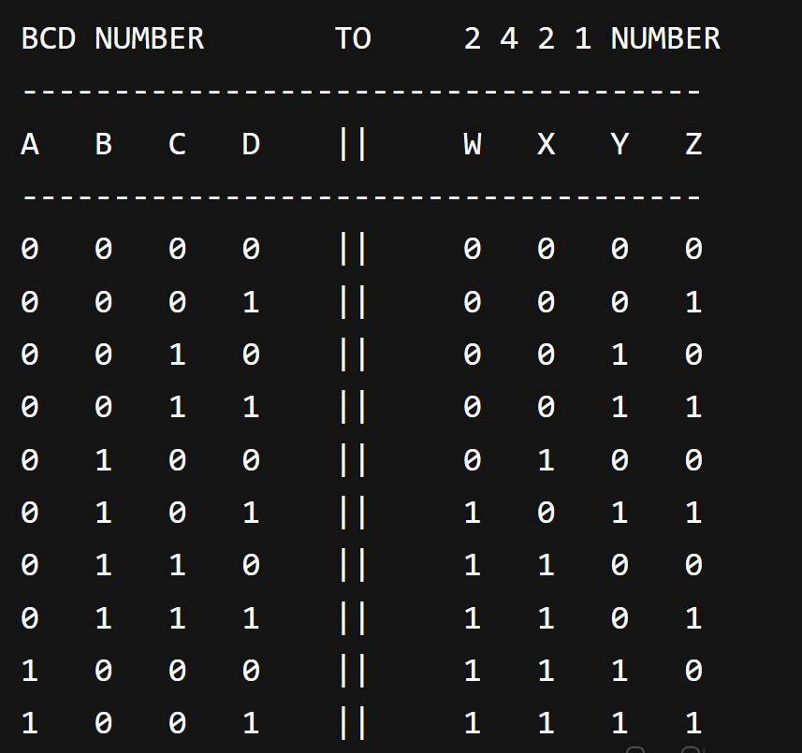

AIM: Design and Implementation of a combination circuit that converts a decimal digit from 84-2-1 code to 5421 code.

CODE:
module decimal( input A, input B, input C, input D, output W, output X, output Y,
output Z
);

assign W = (A & ~C & ~D) || (A & B); assign X = (B & ~C & ~D) || (A & D) || (A & C); assign Y = (C ^ D) || (A & ~C);
assign Z = (A & ~C) || (~B & D) || (~A & D);

endmodule

module decimal_tb;
reg tb_A; reg tb_B; reg tb_C; reg tb_D; wire tb_W; wire tb_X; wire tb_Y;
wire tb_Z;

decimal dut( .A(tb_A),
.B(tb_B),
.C(tb_C),
.D(tb_D),
.W(tb_W),
.X(tb_X),
.Y(tb_Y),
.Z(tb_Z)
);

initial begin tb_A = 1'b0; tb_B = 1'b0; tb_C = 1'b0; tb_D = 1'b0; #10; tb_A = 1'b0; tb_B = 1'b1; tb_C = 1'b1; tb_D = 1'b1; #10; tb_A = 1'b0; tb_B = 1'b1; tb_C = 1'b1; tb_D = 1'b0; #10; tb_A = 1'b0; tb_B = 1'b1; tb_C = 1'b0; tb_D = 1'b1; #10; tb_A = 1'b0; tb_B = 1'b1; tb_C = 1'b0; tb_D = 1'b0; #10; tb_A = 1'b1; tb_B = 1'b0; tb_C = 1'b1; tb_D = 1'b1; #10; tb_A = 1'b1; tb_B = 1'b0; tb_C = 1'b1; tb_D = 1'b0; #10; tb_A = 1'b1; tb_B = 1'b0; tb_C = 1'b0; tb_D = 1'b1; #10; tb_A = 1'b1; tb_B = 1'b0; tb_C = 1'b0; tb_D = 1'b0; #10; tb_A = 1'b1; tb_B = 1'b1; tb_C = 1'b1; tb_D = 1'b1; #10;

$finish ; end
initial begin
$display(" 8 4 -2 -1 NUMBER TO 5 4 2 1 NUMBER ");
$display("-------------------------------------");
$display("A B C D || W X Y Z ");
$display("-------------------------------------");
$monitor("%b %b %b %b || %b %b %b %b ", tb_A, tb_B, tb_C, tb_D, tb_W, tb_X, tb_Y, tb_Z); end endmodule

OUTPUT :

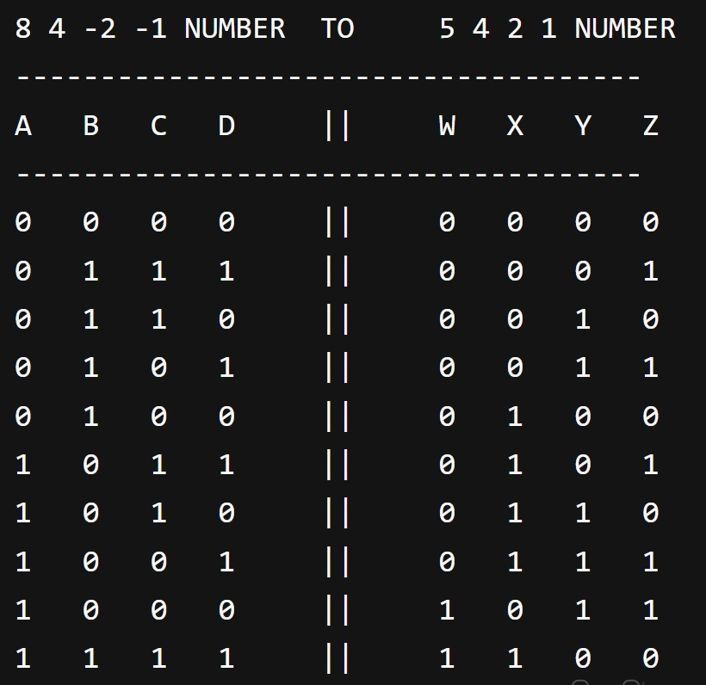

AIM: Design and implementation of a combinational circuit that generates the square of a given 3 bit number.

CODE :
module square(
input X, input Y, input Z, output A, output B, output C, output D, output E, output F
);
assign A = X & Y; assign B = X & (~Y || Z); assign C = Z & (X ^ Y); assign D = Y & ~Z; assign E = 1'b0; assign F = Z;
endmodule module square_tb; reg tb_X; reg tb_Y; reg tb_Z; wire tb_A; wire tb_B; wire tb_C;
wire tb_D; wire tb_E; wire tb_F; square dut( .X(tb_X),
.Y(tb_Y),
.Z(tb_Z),
.A(tb_A),
.B(tb_B),
.C(tb_C),
.D(tb_D),
.E(tb_E),
.F(tb_F)
);
initial begin tb_X = 1'b0; tb_Y = 1'b0; tb_Z = 1'b0; #10; tb_X = 1'b0; tb_Y = 1'b0; tb_Z = 1'b1; #10; tb_X = 1'b0; tb_Y = 1'b1; tb_Z = 1'b0; #10; tb_X = 1'b0; tb_Y = 1'b1; tb_Z = 1'b1; #10; tb_X = 1'b1; tb_Y = 1'b0; tb_Z = 1'b0; #10; tb_X = 1'b1; tb_Y = 1'b0; tb_Z = 1'b1; #10; tb_X = 1'b1; tb_Y = 1'b1; tb_Z = 1'b0; #10; tb_X = 1'b1; tb_Y = 1'b1; tb_Z = 1'b1; #10;
$finish ;
end
initial
begin
$display("SQUARE OF A GIVEN 3-bit NUMBER "); $display("----------------------------------------------");
$display("X Y Z || A B C D E F ");
$display("----------------------------------------------");
$monitor("%b %b %b || %b %b %b %b %b %b ", tb_X, tb_Y, tb_Z, tb_A, tb_B, tb_C, tb_D, tb_E, tb_F); end endmodule
OUTPUT :
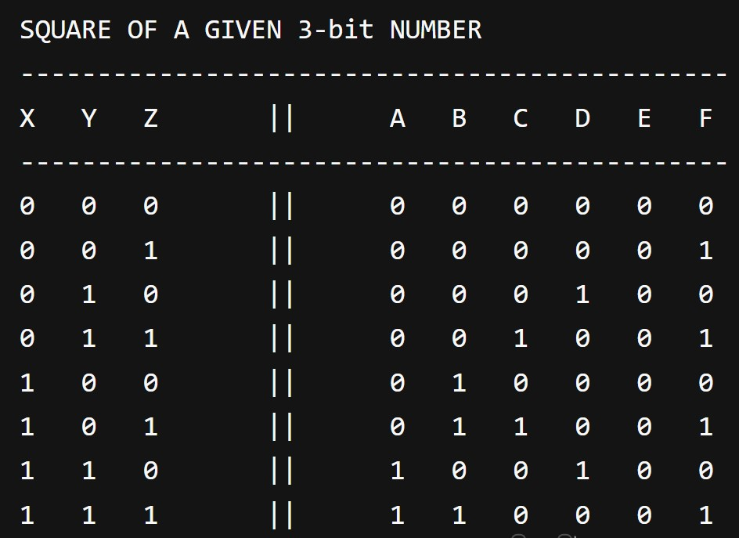

AIM: Design a 4 bit parity generator and checker.

CODE :
module parity(
input A, input B, input C, input D, output P, output checker
);

assign P = ~(A ^ B ^ C ^ D); assign checker = ~(A ^ B ^ C ^ D ^ P);
endmodule

module parity_tb; reg tb_A; reg tb_B; reg tb_C; reg tb_D; wire tb_P; wire tb_checker;

parity dut(
.A(tb_A),
.B(tb_B),
.C(tb_C),
.D(tb_D),
.P(tb_P),
.checker(tb_checker)
);

initial begin tb_A = 1'b0; tb_B = 1'b0; tb_C = 1'b0; tb_D = 1'b0; #10; tb_A = 1'b0; tb_B = 1'b0; tb_C = 1'b0; tb_D = 1'b1; #10; tb_A = 1'b0; tb_B = 1'b0; tb_C = 1'b1; tb_D = 1'b0; #10; tb_A = 1'b0; tb_B = 1'b0; tb_C = 1'b1; tb_D = 1'b1; #10; tb_A = 1'b0; tb_B = 1'b1; tb_C = 1'b0; tb_D = 1'b0; #10; tb_A = 1'b0; tb_B = 1'b1; tb_C = 1'b0; tb_D = 1'b1; #10; tb_A = 1'b0; tb_B = 1'b1; tb_C = 1'b1; tb_D = 1'b0; #10; tb_A = 1'b0; tb_B = 1'b1; tb_C = 1'b1; tb_D = 1'b1; #10; tb_A = 1'b1; tb_B = 1'b0; tb_C = 1'b0; tb_D = 1'b0; #10; tb_A = 1'b1; tb_B = 1'b0; tb_C = 1'b0; tb_D = 1'b1; #10; tb_A = 1'b1; tb_B = 1'b0; tb_C = 1'b1; tb_D = 1'b0; #10; tb_A = 1'b1; tb_B = 1'b0; tb_C = 1'b1; tb_D = 1'b1; #10; tb_A = 1'b1; tb_B = 1'b1; tb_C = 1'b0; tb_D = 1'b0; #10; tb_A = 1'b1; tb_B = 1'b1; tb_C = 1'b0; tb_D = 1'b1; #10; tb_A = 1'b1; tb_B = 1'b1; tb_C = 1'b1; tb_D = 1'b0; #10; tb_A = 1'b1; tb_B = 1'b1; tb_C = 1'b1; tb_D = 1'b1; #10;

$finish ;
end
initial
begin
$display("Parity Generator & Checker ");
$display("-----------------------------------------");
$display("A B C D || Parity Checker ");
$display("-----------------------------------------");
$monitor("%b %b %b %b || %b %b ", tb_A, tb_B, tb_C, tb_D, tb_P, tb_checker); end endmodule
OUTPUT :
